Mix 1 ml water with each Vial of AICAR. one full insulin syringes of water.
Only mix one bottle of each at a time and keep refrigerated.
Most popular dosage is 20ml
Dosage :
40iu of AICAR first thing in the morning, = 20mg
50iu of AICAR first thing in the morning, = 25mg
Ideally your last meal should be a protein source like chicken, fish, lean steak and vegetables. A very small portion of carbs only. Even better if you can do without the carbs on your last meal.
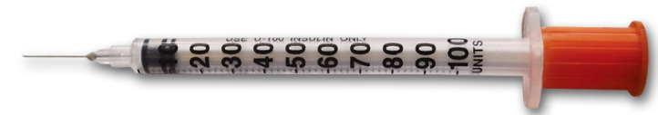
50iu mark
AICAR 25mg
40iu mark
AICAR 20mg

