Mix 1 ml water with each Vial of AICAR. one full insulin syringes of water.

Only mix one bottle of each at a time and keep refrigerated.

Most popular dosage is 20ml

Dosage :

**40iu of AICAR first thing in the morning, = 20mg**

**50iu of AICAR first thing in the morning, = 25mg**

Ideally your last meal should be a protein source like chicken, fish, lean steak and vegetables. A very small portion of carbs only. Even better if you can do without the carbs on your last meal.

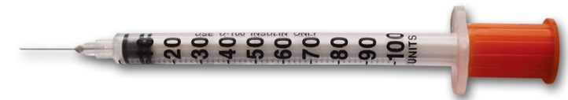

50iu mark  
AICAR 25mg

40iu mark

AICAR 20mg